**MONGO DB WINDOWS INSTALLATION**

1. Locate the downloaded mongoDB msi. File, double click the .msi file.

**SETUP MONGODB ENVIRONMENT**

1. MongoDB requires a data directory to store all data. MongoDB’s default data directory path is the absolute path *\data\db* on the drive from which you start MongoDB. Create this folder by running the following command in a Command Prompt.

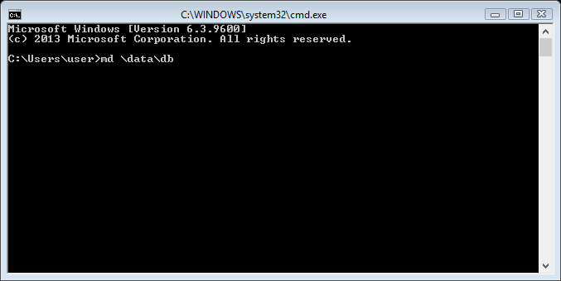

You can also specify an alternate path for data files using the *–dbpath* option to exe.

If you use c:\test\data\db as a path, you need to create first the following folder in directory.

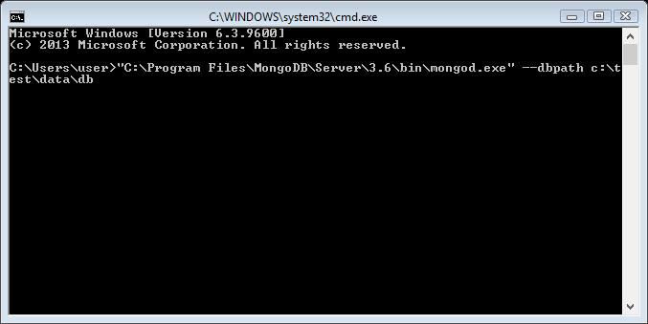

**START MongoDB**

1. To start MongoDB, run exe. For example from the Command Prompt.

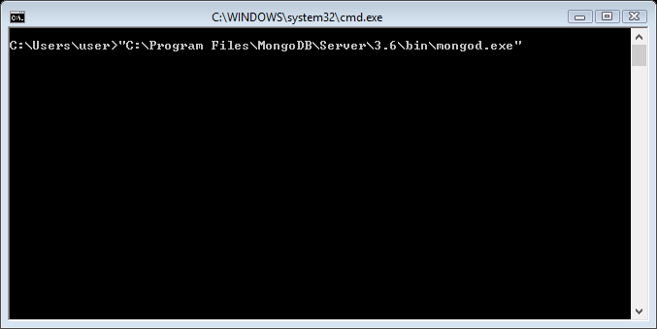

This starts the main MongoDB database process.

**VERIFY MongoDB HAS STARTED**

1. Verify that MongoDB has started successfully by checking the process output for the following line:

*[initiateandlisten] waiting for connections on port 27017*

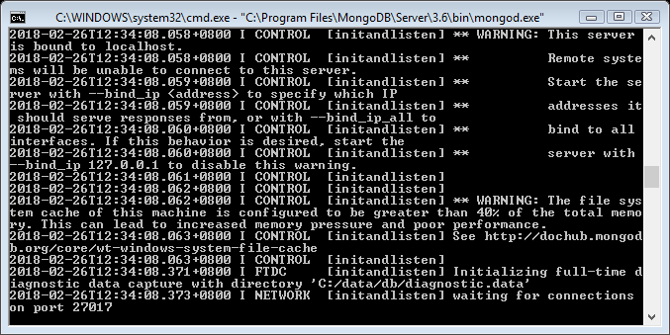

**CONNECT TO MONGODB**

1. To connect to MongoDB through the ~bin.mongo.exe shell, open another Command Prompt.

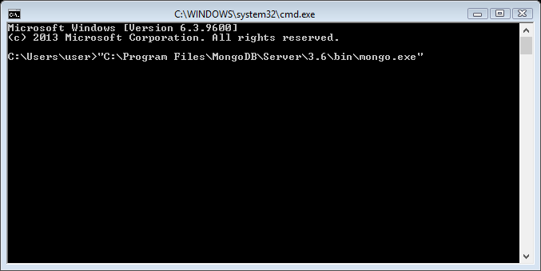

**CONFIGURE A WINDOWS SERVICE FOR MongoDB COMMUNITY EDITION**

1. **Open an Administrator Command Prompt.**
2. **Create Directories**

Create directories for databases and log files.

mkdir c:\data\db

mkdir c:\data\log

1. **Create a configuration file**

Create a configuration file. The file must set the systemlog.path. Include additional configuration options as appropriate.

For example, create a file at c:\Program Files\MongoDB\Server\3.6\mongod.cfg that specifies both *systemlog.path* and *storage.dbpath*.

systemLog:

destination: file

path: c:\test\data\log\mongod.log

storage:

dbPath: c:\test\data\db

1. **Install the MongoDB Service.**

Install the MongoDB service by starting exe with the *--install* option and the *--config* option to specify the previously created configuration file.

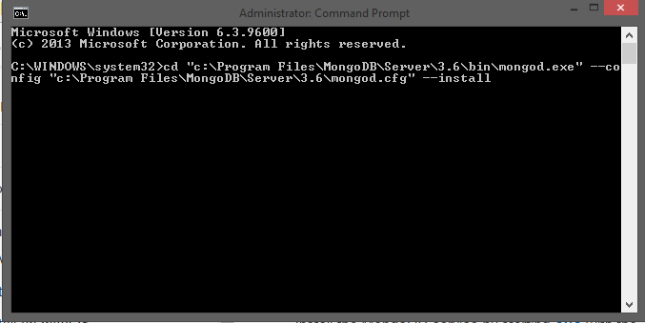

1. **Start the MongoDB Service**

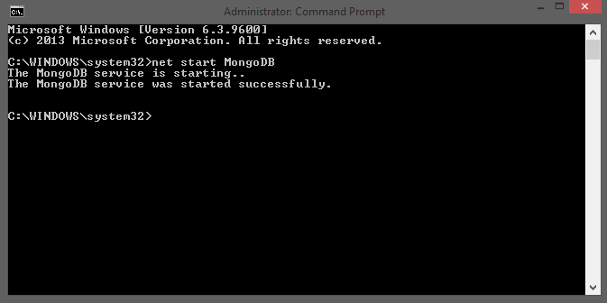

1. **Verify that MongoDB has started successfully.**

Verify the MongoDB has started successfully by checking the log file.

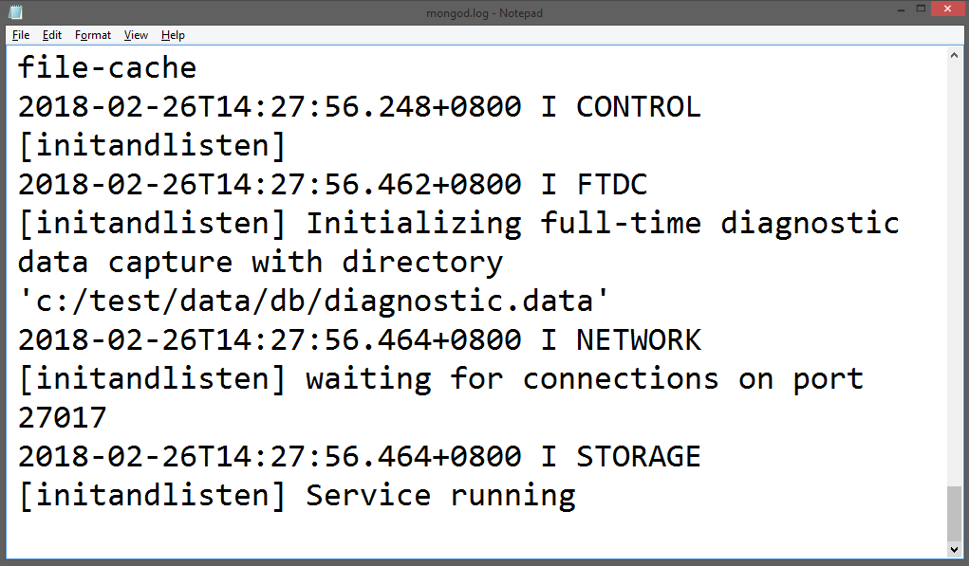

1. **Connect to MongoDB**

To connect to MongoDB through the ~bin.mongo.exe shell, open another Command Prompt.

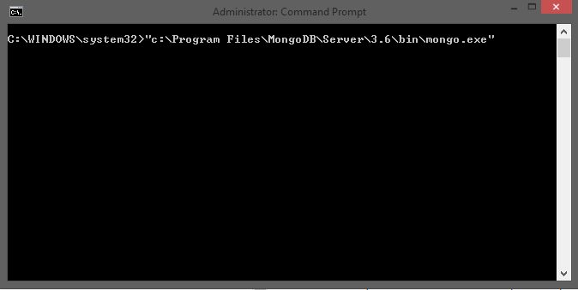

1. **Stop or Remove the MongoDB service as needed.**

To stop the MongoDB service use the following command

